First Part of HW
Part A: Make a chart where you list, Asian American, Latino, Europeans, General Population. Then go through the timeline below and put a checkmark next to each group that illustrates when laws were created to prevent that group from migration or equal opportunity while in the U.S.

Part B: Now state what groups were targeted more as it relates to unfavorable laws toward their immigration.

Part C: Now answer the following questions:
- Do you think this biased behavior created workplace unfairness? (Why or Why not)
- Do you think this bias can still exist today as it relates to certain groups who migrate to the U.S. and people looking at them as an Us vs. Them mindset?Would this mindset contribute to workplace bias?

Timeline
Key Dates and Landmarks in United States Immigration History
 | 1789 | The Constitution of the United States of America takes effect, succeeding the Articles of Confederation that had governed the union of states since the conclusion of the Revolutionary War (March 4, 1789).
 | 1790 | The Naturalization Act of 1790 establishes a uniform rule of naturalization and a two-year residency requirement for aliens who are "free white persons" of "good moral character" (March 26, 1790).
 | 1798 | Considered one of the Alien and Sedition Acts, the Naturalization Act of 1798 permits Federalist President John Adams to deport foreigners deemed to be dangerous and increases the residency requirements to 14 years to prevent immigrants, who predominantly voted for the Republican Party, from becoming citizens (June 25, 1798).
 | 1802 | The Jefferson Administration revises the Naturalization Act of 1798 by reducing the residency requirement from 14 to five years.
 | 1808 | Importation of slaves into the United States is officially banned, though it continues illegally long after the ban.
 | 1819 | Congress passes an act requiring shipmasters to deliver a manifest enumerating all aliens transported for immigration. The Secretary of State is required to report annually to Congress the number of immigrants admitted.
 | 1821–1830 | 143,439 immigrants arrive
 | 1831–1840 | 599,125 immigrants arrive
 | 1840s | Crop failures in Germany, social turbulence triggered by the rapid industrialization of European society, political unrest in Europe, and the Irish Potato Famine (1845–1851) lead to a new period of mass immigration to the United States.
 | 1841–1850 | 1,713,251 immigrants arrive
 | 1848 | The Treaty of Guadalupe Hidalgo ends the Mexican-American War and extends citizenship to the approximately 80,000 Mexicans living in Texas, California, and the American Southwest.
 | 1848 | Gold is discovered in the American River, near Sacramento, California.
 | 1849 | The California gold rush spurs immigration from China and extensive internal migration.
 | 1850 | For the first time, the United States Census surveys the "nativity" of citizens (born inside or outside the US).
 | 1851–1860 | 2,598,214 immigrants arrive
 | 1854 | The Know-Nothings, a nativist political party seeking to increase restrictions on immigration, win significant victories in Congress, a sign of popular dissatisfaction with growing immigration from Catholic Ireland. Protestant Americans feared that growing Catholic immigration would place American society under control of the Pope.
 | 1855 | Castle Garden is established as New York's principal point of entry.
 | 1861–1870 | 2,314,825 immigrants arrive
 | 1861 | Outbreak of the American Civil War (April 12, 1861).
 | 1862 | The Homestead Act provides free plots of up to 160 acres of western land to settlers who agree to develop and live on it for at least five years, thereby spurring an influx of immigrants from overpopulated countries in Europe seeking land of their own.
 | 1862 | The "Anti-Coolie" Act discourages Chinese immigration to California and institutes special taxes on employers who hire Chinese workers.
 | 1863 | Riots against the draft in New York City involve many immigrants opposed to compulsory military service (July 13–16, 1863).
 | 1863 | The Central Pacific hires Chinese laborers and the Union Pacific hires Irish laborers to construct the first transcontinental railroad, which would stretch from San Francisco to Omaha, allowing continuous travel by rail from coast to coast.
 | 1869 | The First Transcontinental Railroad is completed when the Central Pacific and Union Pacific lines meet at Promontory Summit, Utah (May 10, 1869).
 | 1870 | The Naturalization Act of 1870 expands citizenship to both whites and African-Americans, though Asians are still excluded.
 | 1870 | The Fifteenth Amendment is ratified, granting voting rights to citizens, regardless of "race, color, or previous condition of servitude."
 | 1870 | Jacob Riis, who later pioneered photojournalism and authored How the Other Half Lives, emigrates from Denmark to the United States.
 | 1871–1880 | 2,812,191 immigrants arrive
 | 1881–1890 | 5,246,613 immigrants arrive
 | 1881–1885 | 1 million Germans arrive in the peak of German immigration
 | 1881–1920 | 2 million Eastern European Jews immigrate to the United States
 | 1882 | The Chinese Exclusion Act restricts all Chinese immigration to the United States for a period of ten years.
 | 1882 | The Immigration Act of 1882 levies a tax of 50 cents on all immigrants landing at US ports and makes several categories of immigrants ineligible for citizenship, including "lunatics" and people likely to become public charges.
 | 1885 | The Alien Contract Labor Law prohibits any company or individual from bringing foreigners into the United States under contract to perform labor. The only exceptions are those immigrants brought to perform domestic service and skilled workmen needed to help establish a new trade or industry in the US.
 | 1886 | The Statue of Liberty is dedicated in New York Harbor.
 | 1886 | Emma Goldman, Lithuanian-born feminist, immigrates to the United States, where over the next 30 years she will become a prominent American anarchist. During the First World War, in 1917, she is deported to Russia for conspiring to obstruct the draft.
 | 1889 | Jane Addams and Ellen Gates Starr found Hull-House in Chicago.
 | 1890 | The demographic trends in immigration to the United States shift as immigration from Southern and Eastern Europe substantially increases, while the relative proportion of immigration from Northern and Western Europe begins to decrease.
 | 1891–1900 | 3,687,564 immigrants arrive.
 | 1891 | Congress makes "persons suffering from a loathsome or a dangerous contagious disease," those convicted of a "misdemeanor involving moral turpitude," and polygamists ineligible for immigration. Congress also establishes the Office of the Superintendent of Immigration within the Treasury Department.
 | 1892 | The Geary Act extends the Chinese Exclusion Act for ten more years, and adds the requirement that all Chinese residents carry permits, as well as excluding them from serving as witnesses in court and from bail in habeus corpus proceedings.
 | 1892 | Ellis Island, the location at which more than 16 million immigrants would be processed, opens in New York City.
 | 1901–1910 | 8,795,386 immigrants arrive
 | 1901 | After President William McKinley is shot by a Polish anarchist (September 6, 1901) and dies a week later (September 14, 1901), Congress enacts the Anarchist Exclusion Act, which prohibits the entry into the US of people judged to be anarchists and political extremists.
 | 1902 | The Chinese Exclusion Act is again renewed, with no ending date.
 | 1906 | The Naturalization Act of 1906 standardizes naturalization procedures, makes some knowledge of the English language a requirement for citizenship, and establishes the Bureau of Immigration and Naturalization in the Commerce Department to oversee national immigration policy.
 | 1907 | The Expatriation Act declares that an American woman who marries a foreign national loses her citizenship.
 | 1907 | Under an informal "Gentlemen's Agreement," the United States agrees not to restrict Japanese immigration in exchange for Japan's promise to voluntarily restrict Japanese emigration to the United States by not issuing passports to Japanese laborers. In return, the US promises to crack down on discrimination against Japanese-Americans, most of whom live in California.
 | 1907 | The Dillingham Commission is established by Congress to investigate the effects of immigration on the United States.
 | 1911–1920 | 2 million Italians arrive in the peak of Italian immigration
 | 1911–1920 | 5,735,811 immigrants arrive
 | 1911 | The Dillingham Commission, established in 1907, publishes a 42-volume report warning that the "new" immigration from Southern and Eastern Europe threatens to subvert American society. The Dillingham Commission's recommendations lay the foundation for the Quota Acts of the 1920s.
 | 1913 | California's Alien Land Law prohibits "aliens ineligible for citizenship" (Chinese and Japanese) from owning property in the state, providing a model for similar anti-Asian laws in other states.
 | 1917 | Congress enacts a literacy requirement for immigrants by overriding President Woodrow Wilson's veto. The law requires immigrants to be able to read 40 words in some language and bans immigration from Asia, except for Japan and the Philippines.
 | 1917 | The US enters the First World War.
 | 1917 | The Immigration Act of 1917 restricts immigration from Asia by creating an "Asiatic Barred Zone."
 | 1917 | The Jones-Shafroth Act grants US citizenship to Puerto Ricans, provided that they can be recruited by the US military.
 | 1919 | The First Red Scare leads to an outbreak of fear and violence against people deemed to be political radicals and foreigners considered to be susceptible to communist propaganda and more likely to be involved in the Bolshevik Revolution.
 | 1921–1930 | 4,107,209 immigrants arrive.
 | 1921 | The Emergency Quota Act restricts immigration from a given country to 3% of the number of people from that country living in the US in 1910.
 | 1922 | The Cable Act partially repeals the Expatriation Act, but declares that an American woman who marries an Asian still loses her citizenship.
 | 1923 | In the landmark case of United States v. Bhaghat Singh Thind, the Supreme Court rules that Indians from the Asian subcontinent cannot become US citizens.
 | 1924 | The Immigration Act of 1924 limits annual European immigration to 2% of the number of people from that country living in the United States in 1890. The Act greatly reduces immigration from Southern and Eastern European nationalities that had only small populations in the US in 1890.
 | 1924 | The Oriental Exclusion Act prohibits most immigration from Asia, including foreign-born wives and the children of American citizens of Chinese ancestry.
 | 1924 | The Border Patrol is created to combat smuggling and illegal immigration.
 | 1929 | The National Origins Formula institutes a quota that caps national immigration at 150,000 and completely bars Asian immigration, though immigration from the Western Hemisphere is still permitted.
 | 1931–1940 | 532,431 immigrants arrive.
 | 1933 | To escape persecution by the Nazis, Albert Einstein, the greatest theoretical physicist of the century, immigrates to the United States from Germany.
 | 1934 | The Tydings-McDuffe Act grants the Philippines independence from the United States on July 4, 1946, but strips Filipinos of US citizenship and severely restricts Filipino immigration to the United States.
 | 1940 | The Alien Registration Act requires the registration and fingerprinting of all aliens in the United States over the age of 14.

Sources
Calavita, Kitty. US Immigration Law and the Control of Labor: 1820-1924. London, Orlando: Academic Press, 1984.
Digital History: Ethnic Voices.
LeMay, Michael and Robert Barkan Elliott, eds., US Immigration and Naturalization Laws and Issues: A Documentary History. Westport, Conn.: Greenwood Press, 1999.
Smith, Marian L. Overview of INS History to 1998.

Second Part of HW
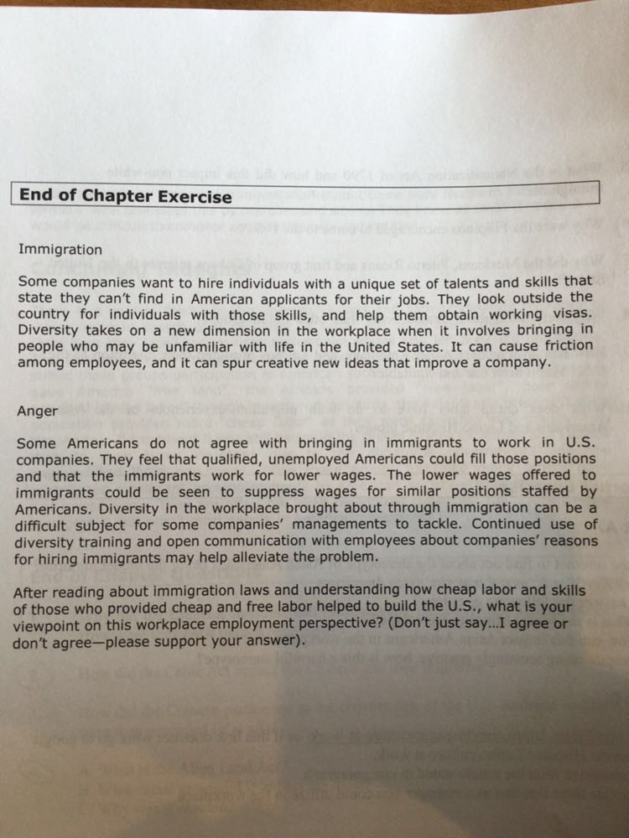

Third part of HW
Article Assignment
Go to http://www.diversityinc.com/ now click on DiversityInc Magazine.
Now choose two articles or videos or recent news clips from the year 2013 or later. Information used earlier than 2013 will result in 0 points. This assignment is all or nothing. You need to complete both articles for the 100 points. If you only complete one article you will receive 0 points.
Requirements for each article:
- State title of article, month/season(winter etc.)and year the article was chosen from. If this information is not included it will not be graded.
- In one paragraph, which is four sentences minimum summarize the article.
- In the next two paragraphs indicate how the information in this article relates to diversity in the workplace, how the information is beneficial or not beneficial and which chapter it relates to best and why.
Here are the chapters topics so that you can answer question 3 correctly.
Chapters Topics:
Background: Business Case for Diversity
Chapter One: Valuing Diversity
Chapter Two: Civil Rights Laws
Chapter Three: Understanding the ISMS
Chapter Four: Understanding the White Male Culture
Chapter Five: Understanding Women and Work
Chapter Six: Understanding the Native American Experience
Chapter Seven: Understanding the African American/Black Experience
Chapter Eight: Understanding the Asian American & Latino Experience
Chapter Nine: Understanding Religious Freedom & Work
Chapter Ten: Understanding the Disabled
Chapter Eleven: Affirmative Action
Chapter Twelve: Managing Diversity Strategies.

